Dynamic Facilitation Associates
1040 Taylor Street
Port Townsend, WA 98368
Address Service Requested
“A mind-expanding experience of an alternative approach to group discussion and problem-solving,” Carol Chetkovich, Professor, Harvard Kennedy School of Government
“Dynamic Facilitation reminds me of white water kayaking: you just put your paddle into the water at a certain angle and the power of the water can spin the boat. The power of the water (in this case, the group energy) does all the work,” Elly Adelman, Bonneville Power
“I found a way to facilitate for monumental change...” Glenn Floyd, OD/HR Internal Consultant

What Others Are Saying…
Sponsor a Dynamic Facilitation Seminar in Your Community
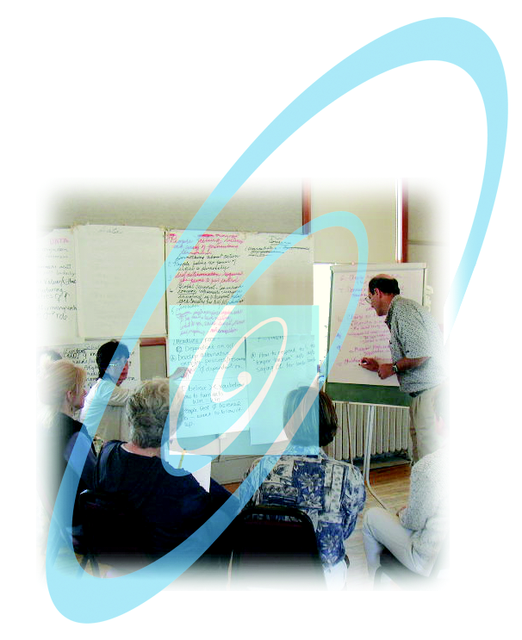

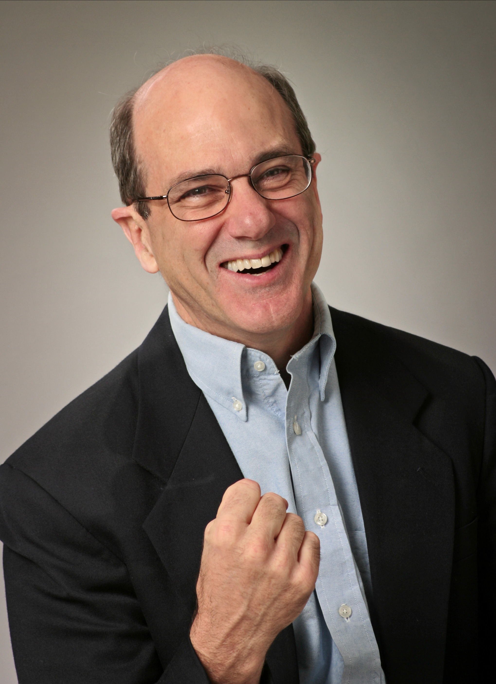
Dynamic Facilitation is…
a NEW way of facilitating people to address difficult issues collaboratively and creatively and reach rapid consensus…

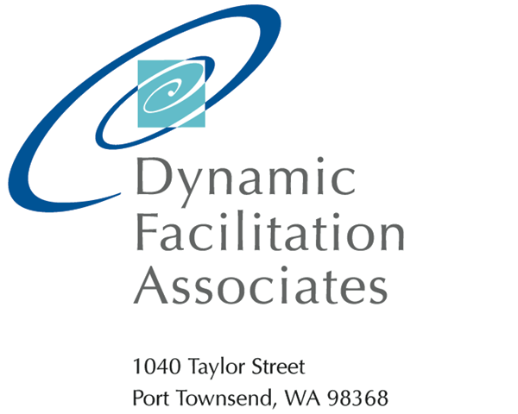

About Jim Rough
Since 1980, Jim has been a faculty member at the annual Creative Problem Solving Institute. He has spoken at conferences, published articles and is working on a new book about Dynamic Facilitation. Before founding Jim Rough and Associates, Inc. (Dynamic Facilitation Associates) in 1985, Jim worked as an internal consultant within Boeing, Xerox and Simpson Timber Company. His education includes a B.A. in physics from Occidental College, M.S. and M.B.A. degrees from Columbia University and many years of independent study in Jungian psychology.
Jim Rough is the originator and principal seminar leader for Dynamic Facilitation Skills. He has been leading public seminars and evolving Dynamic Facilitation for over 20 years.

Dynamic Facilitation
The best result of a meeting is when people have a breakthrough – then everyone understands and supports the decision. A breakthrough is a consensus process, only fast… and with trust, enthusiasm and personal growth as well.

Dynamic Facilitation maximizes the possibility of breakthroughs by stimulating high quality thinking, or Choice-creating. Choice-Creating is a creative thinking process which can be applied to even the most difficult situations. It’s not a “decision-making” process, but a creative process with frequent shifts of mind and heart. New and better options are arrived at with enthusiasm.

The Dynamic Facilitation Skills Seminar has been Wow!-ing people since 1990. It empowers participants to a new level of facilitative competence – how to help others address difficult issues creatively and collaboratively, where they achieve breakthrough results.

Visit www.DynamicFacilitation.com for more information on the theory and practice of
Dynamic Facilitation.
Bring Dynamic Facilitation to your community by sponsoring a seminar!

You’ll receive:
- Top quality instruction by the originator of Dynamic Facilitation, Jim Rough
- Dynamic Facilitation Manuals and Workbooks for every participant
- Publicity for your organization through recognition in all marketing materials
- A free space in the seminar, with additional discount opportunities for your organization

Benefits to your organization and/or community are numerous:
- Seminar participants leave with skills to amplify breakthrough quality for your entire community;
- Individuals with interest can continue on the road to certification in Dynamic Facilitation training, bringing resources for ongoing education into the community;
- You’ll get to work on and solve issues shared by everyone;
- A network of locally-trained people with whom you can stay in touch and continue building your skill; and
- Up the level of creativity and problem-solving capability for the whole community – participants become a “we”, and that “we” grows.

Seminar Details

Make It Happen
Sponsor Responsibilities:
Dynamic Facilitation Associates will partner with you to arrange seminar details, including a location, materials and publicity for the seminar.

Tuition & Fees:
Tuition is based on a 3-tier format for Corporate, Government and Nonprofit employees. Discounts and income-generating pricing scales are negotiated with sponsoring individuals or organizations based on seminar specifics. Call us to discuss these unique opportunities.

Days & Times:
Seminars can be arranged as 3-day or
4-day classes; sessions last 8:30 AM to 4:30 PM each day.

Contact Us:
To find out more, call Jean Rough
at 360-385-7118 or info@dynamicfacilitation.com

